# TNSDC-NAAN MUDHALVAN(IBM)

## COLLEGE CODE:7240

**COLLEGE NAME: Dhaanish Ahmed Institute of Technology**

**DOMAIN: APPLIED DATA SCIENCE**

## PROJECT: FUTURE SALES PREDICTION

**PROBLEM STATEMENT**

* **Importing libraries**
* **Versions of packages**
* **Python version**
* **Importing the data**
* **Handling the missing data**
* **Encoding the Categorical Data**
* **Splitting the dataset**
* **Feature scaling**

## Importing Libraries:

import numpy as np import pandas as pd

import seaborn as sns

import matplotlib.pyplot as plt

import gc

from itertools import product import pickle

import time

from sklearn.preprocessing import LabelEncoder

%matplotlib inline

**Versions of packages:**

import pkg_resources import types

def get_imports():

for name, val **in** globals().items():

if isinstance(val, types.ModuleType):

*# Split ensures you get root package, # not just imported function*

name = val. name .split(".")[0]

elif isinstance(val, type):

name = val. module .split(".")[0]

*# Some packages are weird and have different # imported names vs. system names*

if name == "PIL": name = "Pillow"

elif name == "sklearn": name = "scikit-learn"

yield name

imports = list(set(get_imports()))

requirements = []

for m **in** pkg_resources.working_set:

if m.project_name **in** imports **and** m.project_name!="pip": requirements.append((m.project_name, m.version))

for r **in** requirements: print("**{}**==**{}**".format(*r))

## Output:

seaborn==0.10.0 scikit-learn==0.23.2 pandas==1.1.2 numpy==1.18.5 matplotlib==3.2.1

## Python version:

import sys print(sys.version)

Output:

3.7.6 | packaged by conda-forge | (default, Mar 23 2020, 23:03:20) [GCC 7.3.0]

**Reading in the data:**

input_path = "../input/competitive-data-science-predict-future-sales/" train = reduce_mem_usage(pd.read_csv(input_path + "sales_train.csv"))

## Exploratory data analysis:

pd.to_datetime(train.date).value_counts().sort_index(ascending=False).p lot(kind='line')

fig = plt.gcf()

fig.set_size_inches(20, 8) plt.ylabel("transactions")

**Output:**

Text(0, 0.5, 'transactions')

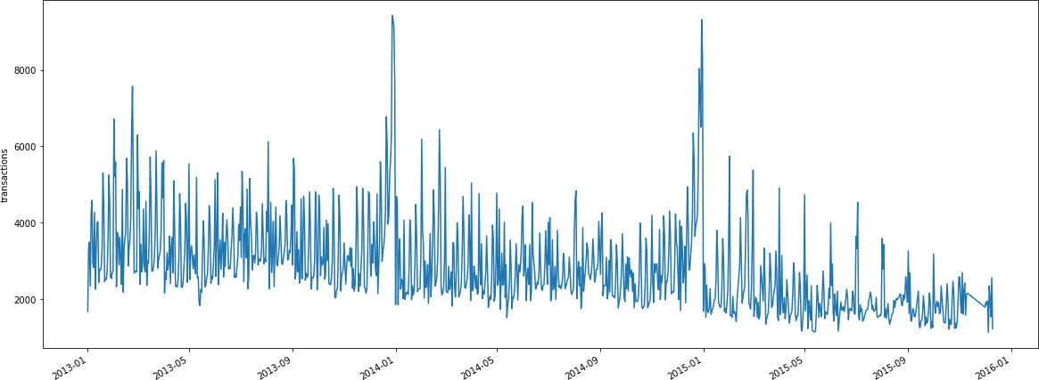

merged_train = pd.merge(train, items, on='item_id', how='inner') merged_train = pd.merge(merged_train, cats, on='item_category_id', how= 'inner')

merged_train = pd.merge(merged_train, shops, on='shop_id', how='inner') merged_train['revenue'] = merged_train['item_price'] * merged_train['i tem_cnt_day']

merged_train.item_category_name.value_counts().plot(kind='bar') fig = plt.gcf()

fig.set_size_inches(20, 8) plt.ylabel("transactions") plt.xlabel("categories") plt.show()

merged_train.groupby('shop_name')['revenue'].sum().sort_values(ascendin g=False).plot(kind='bar')

fig = plt.gcf() fig.set_size_inches(20, 8) plt.ylabel("revenue") plt.xlabel("shops") plt.show()

del merged_train gc.collect()

## Output:

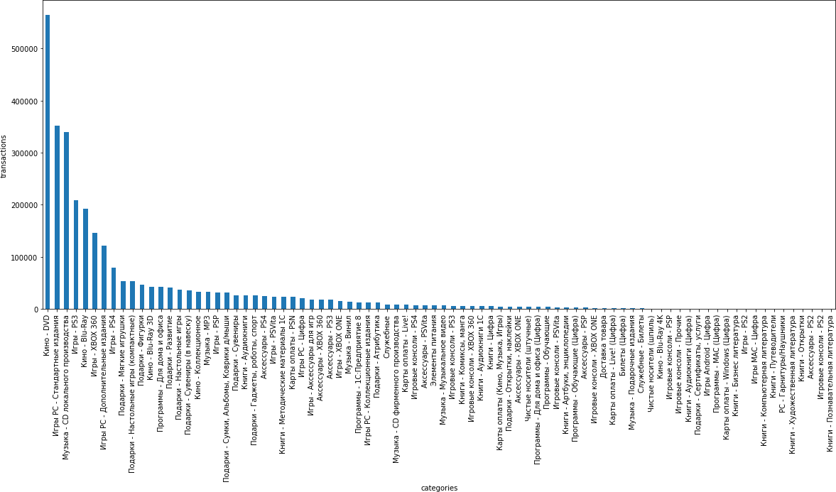

**Output:**

**12392**

**As we can see, there are a couple of outliers and negative item prices:**

plt.xlim(-100, 3000) sns.boxplot(x=train.item_cnt_day)

plt.figure(figsize=(10,4))

plt.xlim(train.item_price.min(), train.item_price.max()*1.1) sns.boxplot(x=train.item_price)

## Output:

<matplotlib.axes._subplots.AxesSubplot at 0x7f3d904d85d0>

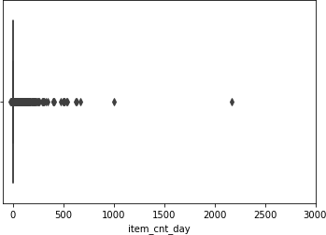

## Feature engineering:

***# measure time it took for feature preprocessing***

start_time = time.time()

**Data Cleaning:**

**Removing the outliers and negative item prices.**

train = train[(train.item_price < 100000) & (train.item_price > 0)] train = train[train.item_cnt_day < 1001]

Some shops are duplicates. Merge them

train.loc[train.shop_id == 0, 'shop_id'] = 57

test.loc[test.shop_id == 0, 'shop_id'] = 57

train.loc[train.shop_id == 1, 'shop_id'] = 58

test.loc[test.shop_id == 1, 'shop_id'] = 58

train.loc[train.shop_id == 10, 'shop_id'] = 11

test.loc[test.shop_id == 10, 'shop_id'] = 11

## Basic Feature Engineering + Extracting text features:

*# REVENUE*

train['revenue'] = train['item_price'] * train['item_cnt_day']

*# CITY NAME text feature # city is before each shop*

shops.loc[shops.shop_name == 'Сергиев Посад ТЦ "7Я"',"shop_name"] = 'Се ргиевПосад ТЦ "7Я"'

shops['city'] = shops['shop_name'].str.split(' ').map(lambda x: x[0]) shops.loc[shops.city == '!Якутск', 'city'] = 'Якутск' shops['city_code'] = LabelEncoder().fit_transform(shops['city']).astype (np.int8) *# Applying label encoding*

*# SHOP CATEGORY text feature*

shops["category"] = shops.shop_name.str.split(" ").map( lambda x: x[1]

)

category = []

for cat **in** shops.category.unique():

if len(shops[shops.category == cat]) >= 5: category.append(cat)

shops.category = shops.category.apply( lambda x: x if (x **in** category) e lse "other" )

shops['category_code'] = LabelEncoder().fit_transform(shops['category']

).astype(np.int8) *# Applying label encoding*

*# POPULATION*

population = {'Якутск': 269601, 'Адыгея':144249, 'Балашиха': 215494, 'В олжский': 314255, 'Вологда': 301755, 'Воронеж': 889680,

'Жуковский': 104736, 'Казань': 1143535, 'Калуга':324698,

'Коломна': 144589, 'Красноярск': 973826, 'Курск': 415159, 'Москв

а':11503501, 'Мытищи': 173160, 'Н.Новгород': 1250619,

'Новосибирск': 1473754, 'Омск': 1154116, 'РостовНаДону': 1089261

, 'СПб': 4879566, 'Самара': 1164685,

'СергиевПосад': 111179, 'Сургут': 306675, 'Томск': 524669, 'Тюме

нь': 581907, 'Уфа': 1062319, 'Химки': 207425,

'Чехов': 60720, 'Ярославль': 591486}

*# filling the online store and other non-locations with mean* mean_population = int(np.mean([v for k, v **in** population.items()])) population['Выездная'] = mean_population

population['Интернет-магазин'] = mean_population population['Цифровой'] = mean_population

shops['city_population'] = shops['city'].map(lambda x: population[x]).a stype(np.int32)

*# COORDINATES*

*# lattitude and longitude of the cities*

coords = dict()

coords['Якутск'] = (62.028098, 129.732555, 4)

coords['Адыгея'] = (44.609764, 40.100516, 3)

coords['Балашиха'] = (55.8094500, 37.9580600, 1)

coords['Волжский'] = (53.4305800, 50.1190000, 3)

coords['Вологда'] = (59.2239000, 39.8839800, 2)

coords['Воронеж'] = (51.6720400, 39.1843000, 3)

coords['Выездная'] = (0, 0, 0)

coords['Жуковский'] = (55.5952800, 38.1202800, 1)

coords['Интернет-магазин'] = (0, 0, 0)

coords['Казань'] = (55.7887400, 49.1221400, 4)

coords['Калуга'] = (54.5293000, 36.2754200, 4)

coords['Коломна'] = (55.0794400, 38.7783300, 4)

coords['Красноярск'] = (56.0183900, 92.8671700, 4)

coords['Курск'] = (51.7373300, 36.1873500, 3)

coords['Москва'] = (55.7522200, 37.6155600, 1)

coords['Мытищи'] = (55.9116300, 37.7307600, 1)

coords['Н.Новгород'] = (56.3286700, 44.0020500, 4)

coords['Новосибирск'] = (55.0415000, 82.9346000, 4)

coords['Омск'] = (54.9924400, 73.3685900, 4)

coords['РостовНаДону'] = (47.2313500, 39.7232800, 3)

coords['СПб'] = (59.9386300, 30.3141300, 2)

coords['Самара'] = (53.2000700, 50.1500000, 4)

coords['СергиевПосад'] = (56.3000000, 38.1333300, 4)

coords['Сургут'] = (61.2500000, 73.4166700, 4)

coords['Томск'] = (56.4977100, 84.9743700, 4)

coords['Тюмень'] = (57.1522200, 65.5272200, 4)

coords['Уфа'] = (54.7430600, 55.9677900, 4)

coords['Химки'] = (55.8970400, 37.4296900, 1)

coords['Цифровой'] = (0, 0, 0)

coords['Чехов'] = (55.1477000, 37.4772800, 4)

coords['Ярославль'] = (57.6298700, 39.8736800, 2)

shops['city_coord_1'] = shops['city'].apply(lambda x: coords[x][0]).ast ype(np.float16)

shops['city_coord_2'] = shops['city'].apply(lambda x: coords[x][1]).ast ype(np.float16)

shops['country_part'] = shops['city'].apply(lambda x: coords[x][2]).ast ype(np.int8)

*# SHOP TYPE*

cats['split'] = cats['item_category_name'].str.split('-') *# item catego ry name is 'type-subtype'*

cats['type'] = cats['split'].map(lambda x: x[0].strip()) cats['type_code'] = LabelEncoder().fit_transform(cats['type']).astype(n p.int8) *# Applying label encoding*

cats['subtype'] = cats['split'].map(lambda x: x[1].strip() if len(x) >

1 else x[0].strip())

cats['subtype_code'] = LabelEncoder().fit_transform(cats['subtype']).as type(np.int8) *# Applying label encoding*

## Selecting only the wanted columns:

*# dropping unnecessary columns*

cats = cats[['item_category_id','type_code', 'subtype_code']]

shops = shops[['shop_id','city_code', 'city_coord_1', 'city_coord_2', '

country_part', 'city_population', 'category_code']] items.drop(['item_name'], axis=1, inplace=True)

### Generate all combinations of items and shops for each month:

matrix = []

cols = ["date_block_num", "shop_id", "item_id"] for i **in** range(34):

sales = train[train.date_block_num == i]

matrix.append( np.array(list( product( [i], sales.shop_id.unique(), sales.item_id.unique() ) ), dtype = np.int16) )

matrix = pd.DataFrame( np.vstack(matrix), columns = cols ) matrix["date_block_num"] = matrix["date_block_num"].astype(np.int8) matrix["shop_id"] = matrix["shop_id"].astype(np.int8) matrix["item_id"] = matrix["item_id"].astype(np.int16)

matrix.sort_values( cols, inplace = True )

Calculating monthly items sold (target).

Filling missing values with zeros and clipping targets into [0,20] as suggested

group = train.groupby(['date_block_num','shop_id','item_id']).agg({'ite m_cnt_day': ['sum']})

group.columns = ['item_cnt_month'] group.reset_index(inplace=True)

matrix = pd.merge(matrix, group, on=cols, how='left') matrix['item_cnt_month'] = (matrix['item_cnt_month']

.fillna(0)

.clip(0,20)

.astype(np.float16))

### Adding the correct block number to the test set :

test['date_block_num'] = 34

test['date_block_num'] = test['date_block_num'].astype(np.int8)

matrix = pd.concat([matrix, test], ignore_index=True, sort=False, keys= cols)

matrix.fillna(0, inplace=True)

**Merging the dataframes:**

matrix = pd.merge(matrix, shops, on=['shop_id'], how='left') matrix = pd.merge(matrix, items, on=['item_id'], how='left')

matrix = pd.merge(matrix, cats, on=['item_category_id'], how='left')

### Lagging features:

*# lagging features*

def lag_feature(df, lags, col):

tmp = df[['date_block_num','shop_id','item_id',col]] for i **in** lags:

shifted = tmp.copy()

shifted.columns = ['date_block_num','shop_id','item_id', col+'_ lag_'+str(i)]

shifted['date_block_num'] += i

df = pd.merge(df, shifted, on=['date_block_num','shop_id','item

_id'], how='left') return df

*# lagged feature for item with id one less than current item*

def lag_feature_adv(df, lags, col):

tmp = df[['date_block_num','shop_id','item_id',col]] for i **in** lags:

shifted = tmp.copy()

shifted.columns = ['date_block_num','shop_id','item_id', col+'_ lag_'+str(i)+'_adv']

shifted['date_block_num'] += i shifted['item_id'] -= 1

df = pd.merge(df, shifted, on=['date_block_num','shop_id','item

_id'], how='left')

df[col+'_lag_'+str(i)+'_adv'] = df[col+'_lag_'+str(i)+'_adv'].a stype('float16')

return df

### Generated lagged features:

*# generating lagged features*

matrix = lag_feature(matrix, [1, 2, 3, 6, 12], 'item_cnt_month')

matrix = lag_feature_adv(matrix, [1, 2, 3, 6, 12], 'item_cnt_month')

**Mean encoded lagged features**

Generating mean encoded features

def mean_encoded_feature(df, group_by, feature, new_feature, lags=[1]):

*# mean encoding the feature*

group = df.groupby(group_by).agg({feature: ['mean']}) group.columns = [new_feature] group.reset_index(inplace=True)

df = pd.merge(df, group, on=group_by, how='left') df[new_feature] = df[new_feature].astype(np.float16)

*# Lagging the mean encoded feature*

df = lag_feature(df, lags, new_feature)

*# Removing for the current month* df.drop([new_feature], axis=1, inplace=True) return df

*# mean encoding various features*

matrix = mean_encoded_feature(matrix, ['date_block_num'], 'item_cnt_mon th', 'date_target_enc', [1])

matrix = mean_encoded_feature(matrix, ['date_block_num', 'item_id'], 'i tem_cnt_month', 'date_item_target_enc', [1,2,3,6,12])

matrix = mean_encoded_feature(matrix, ['date_block_num', 'shop_id'], 'i tem_cnt_month', 'date_shop_target_enc', [1,2,3,6,12])

matrix = mean_encoded_feature(matrix, ['date_block_num', 'item_id', 'sh op_id'], 'item_cnt_month', 'date_item_shop_target_enc', [1,2,3])

matrix = mean_encoded_feature(matrix, ['date_block_num', 'item_category

_id'], 'item_cnt_month', 'date_cat_target_enc', [1])

matrix = mean_encoded_feature(matrix, ['date_block_num', 'shop_id', 'it em_category_id'], 'item_cnt_month', 'date_shop_cat_target_enc', [1]) matrix = mean_encoded_feature(matrix, ['date_block_num', 'shop_id', 'ty pe_code'], 'item_cnt_month', 'date_shop_type_target_enc', [1])

**Revenue features**

*# Total monthly revenue for each shop*

group = train.groupby(['date_block_num','shop_id']).agg({'revenue': ['sum']

})

group.columns = ['date_shop_revenue'] group.reset_index(inplace=True)

matrix = pd.merge(matrix, group, on=['date_block_num','shop_id'], how='left ')

matrix['date_shop_revenue'] = matrix['date_shop_revenue'].astype(np.float32

)

*# total average revenue for each shop*

group = group.groupby(['shop_id']).agg({'date_shop_revenue': ['mean']})

group.columns = ['shop_avg_revenue'] group.reset_index(inplace=True)

matrix = pd.merge(matrix, group, on=['shop_id'], how='left') matrix['shop_avg_revenue'] = matrix['shop_avg_revenue'].astype(np.float32)

*# Monthly revenue difference from the average divided by the average revenue for scaling*

matrix['delta_revenue'] = (matrix['date_shop_revenue'] - matrix['shop_avg_r evenue']) / matrix['shop_avg_revenue']

matrix['delta_revenue'] = matrix['delta_revenue'].astype(np.float16)

*# Lagging the feature*

matrix = lag_feature(matrix, [1], 'delta_revenue')

matrix.drop(['date_shop_revenue','shop_avg_revenue','delta_revenue'], axis= 1, inplace=True)

**Date features:**

import calendar

*# month number from 0 to 11*

matrix['month'] = matrix['date_block_num'] % 12

days = pd.Series([31,28,31,30,31,30,31,31,30,31,30,31])

*# days in each month*

matrix['days'] = matrix['month'].map(days).astype(np.int8)

*# number of weekends each month*

def weekends(date_block_num):

month = date_block_num % 12 + 1 year = 2013 + date_block_num // 12

return len([1 for i **in** calendar.monthcalendar(year, month) if i[6]

!= 0])

matrix['weekends'] = matrix['date_block_num'].apply(lambda x: weekends( x)).astype(np.int8)

**Item date features (interactions)**

Finding when item first appeared and when it was first bought.

*# item first appeared*

first_item_block = matrix.groupby(['item_id'])['date_block_num'].min(). reset_index()

first_item_block['item_first_interaction'] = 1

*# item first bought*

first_shop_item_buy_block = matrix[matrix['date_block_num'] > 0].groupb y(['shop_id', 'item_id'])['date_block_num'].min().reset_index()

first_shop_item_buy_block['first_date_block_num'] = first_shop_item_buy

_block['date_block_num']

matrix = pd.merge(matrix, first_item_block[['item_id', 'date_block_num'

, 'item_first_interaction']], on=['item_id', 'date_block_num'], how='le ft')

matrix = pd.merge(matrix, first_shop_item_buy_block[['item_id', 'shop_i d', 'first_date_block_num']], on=['item_id', 'shop_id'], how='left')

matrix['first_date_block_num'].fillna(100, inplace=True) matrix['shop_item_sold_before'] = (matrix['first_date_block_num'] < mat rix['date_block_num']).astype('int8') matrix.drop(['first_date_block_num'], axis=1, inplace=True)

matrix['item_first_interaction'].fillna(0, inplace=True) matrix['shop_item_sold_before'].fillna(0, inplace=True)

*# is it the first time the item appears* matrix['item_first_interaction'] = matrix['item_first_interaction'].ast ype('int8')

*# average category sales for the new item*

item_id_target_mean = matrix[matrix['item_first_interaction'] == 1].gro upby(['date_block_num','subtype_code'])['item_cnt_month'].mean().reset_ index().rename(columns={

"item_cnt_month": "new_item_cat_avg"}, errors="raise")

matrix = pd.merge(matrix, item_id_target_mean, on=['date_block_num','su btype_code'], how='left')

matrix['new_item_cat_avg'] = (matrix['new_item_cat_avg']

.fillna(0)

.astype(np.float16))

matrix = lag_feature(matrix, [1, 2, 3], 'new_item_cat_avg') matrix.drop(['new_item_cat_avg'], axis=1, inplace=True)

*# average category sales for the new item in each store* item_id_target_mean = matrix[matrix['item_first_interaction'] == 1].gro upby(['date_block_num','subtype_code', 'shop_id'])['item_cnt_month'].me an().reset_index().rename(columns={

"item_cnt_month": "new_item_shop_cat_avg"}, errors="raise")

matrix = pd.merge(matrix, item_id_target_mean, on=['date_block_num','su btype_code', 'shop_id'], how='left')

matrix['new_item_shop_cat_avg'] = (matrix['new_item_shop_cat_avg']

.fillna(0)

.astype(np.float16))

matrix = lag_feature(matrix, [1, 2, 3], 'new_item_shop_cat_avg') matrix.drop(['new_item_shop_cat_avg'], axis=1, inplace=True)

### Time since first sale and since first sale at the shop

*# months since first sale in the shop*

matrix['item_shop_first_sale'] = matrix['date_block_num'] - matrix.grou pby(['item_id','shop_id'])['date_block_num'].transform('min')

*# months since first sale over all shops*

matrix['item_first_sale'] = matrix['date_block_num'] - matrix.groupby(' item_id')['date_block_num'].transform('min')

**Final Touches:**

*# fill the nan's caused by lagging the features*

def fill_na(df):

for col **in** df.columns:

if ('_lag_' **in** col) & (df[col].isnull().any()): df[col].fillna(0, inplace=True)

return df

matrix = fill_na(matrix)

**Saving for quicker loading later:**

*# saving all the data*

matrix.to_pickle('all_data.pkl')

*# data for using 12 month lags (first 12 months already removed)*

matrix = matrix[matrix.date_block_num > 11] matrix.to_pickle('data.pkl')

*# measuring the time the preprocessing and feature engineering took*

end_time = time.time()

print(f"Preprocessing took **{**end_time - start_time**}**s")

## Preprocessing took 649.7621595859528s

**Algorithm for the feature Engineering:**

* Imputation. Imputation deals with handling missing values in data. ...
* Discretization. ...
* Categorical Encoding. ...
* Feature Splitting. ...
* Handling Outliers. ...
* Variable Transformations. ...
* Scaling. ...
* Feature Creation in Machine Learning.

1. **Model Training:**

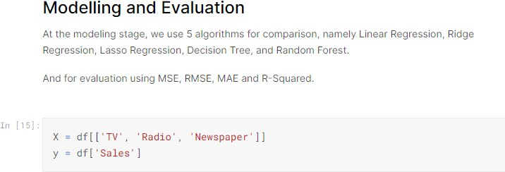

Once the features are prepared, the next step is to train a machine learning model. You can use various regression algorithms for IMDb score prediction. Some popular choices include:

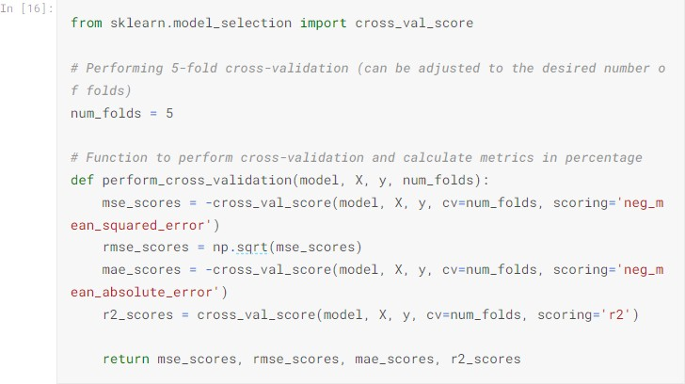

* Linear Regression
* Decision Trees
* Random Forest
* Gradient Boosting
* Neural Networks



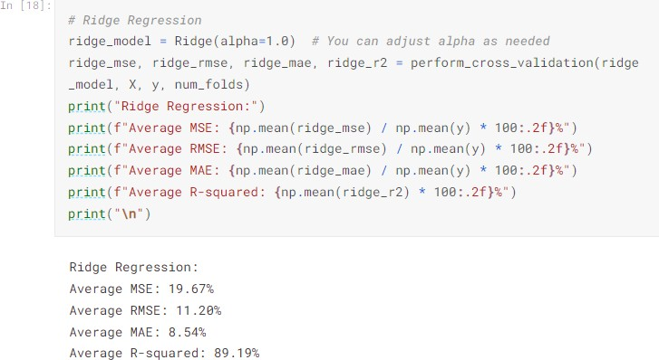

# Evalution:

Evaluating the performance of your IMDb score prediction model is crucial to ensure it provides accurate and reliable results. Several metrics can be used for evaluation, such as:

* Mean Squared Error (MSE): This measures the average squared difference between predicted and actual IMDb scores.
* Root Mean Squared Error (RMSE): The square root of the MSE, which provides a more interpretable measure.
* Mean Absolute Error (MAE): This calculates the average absolute difference between predicted and actual IMDb scores.
* R-squared (R2): A measure of how well the model explains the variance in the data.